Mobile User Experience

6MMCS001W

Coursework 1 Report - Mobile App Design

Author:

Student ID:

Group Number:

[As in Excel sheet]

Links to WebSite:

URL:

# **Content**

Content 2

1. Discussion of UI and application of mobile UX principles 3

1.1 Mobile Information architecture & Navigation 3

a. Design 3

1.2 Emotional design 3

1.3 Use of colour 4

Design 4

Code to achieve good colour balance & ensure consistency 4

1.3 Typography / consistency 4

Design 4

Code to ensure consistency 4

1.4 Photography / consistency 4

Design 4

Code to achieve good colour balance & ensure consistency 4

1.5 Gestalt principles grouping 5

Design 5

1.6 System response & feedback 5

1.7 Gamification 5

1.8 Directing the user to content and use of emphasis 5

1.6 iPhone vs iPad 6

Design 6

References 6

# **Discussion of UI and application of mobile UX principles**

This mobile web app represents a platform for the promotion of numerous items at a large supermarket, both in-store and online.Users may get information about numerous items and place purchases using this website.The mobile site allows the giant supermarket to showcase their items to a wider range and a large number of clients.The mobile web app also provides capabilities for customers to discover product information and exchange product information.The mobile site is created for this purpose, as detailed in the following sections.

**1.1 Mobile Information architecture & Navigation**

**a. Design**

The main structure of the application.

Our app is a marketing mobile web app for a grocery store named "FOODSCO".The mobile application is divided into sections so that the user can comprehend the program's flow.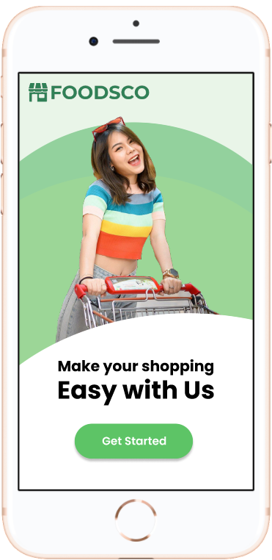

When a user initially accesses the program, he or she must log in to the system in order to proceed to the next level. This program also provides a registration option for new users.

For the Mobile Information Architecture, we selected a common paradigm that most mobile app users are acquainted with.**Tabbed View** is a collection of parts linked together by a toolbar menu that allows the user to swiftly browse and get an understanding of the application's features.This strategy will be one of the most important components in attracting users.The tabbed view application is appropriate for the program's multitasking characteristics and comparable themes.([Designing The Information Architecture (IA) of Mobile Apps | Applikey (applikeysolutions.com)](https://applikeysolutions.com/blog/designing-the-information-architecture-ia-of-mobile-apps)).

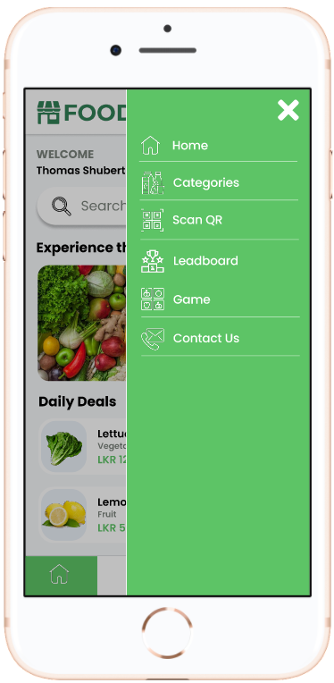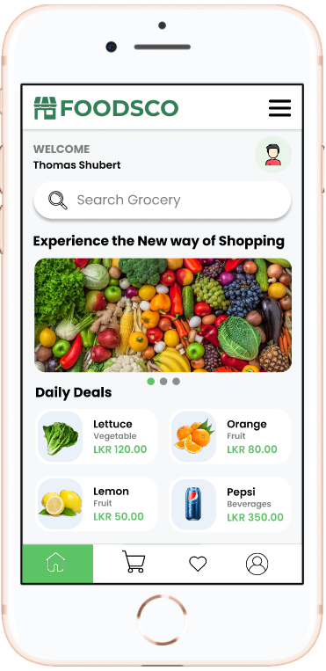

After registering the user will navigate to the home page where in figure 1 shows the information presented to the user in a small and straightforward style. The user will be able to understand the types of items sold through the application by using the many types of categories accessible such as daily deals.

There is also a search box on the home page and categories page. This feature was created to help people who are looking for a certain product. These users require immediate access to the product and would want to look for it immediately in order to save time.

**Navigation**

Header Navigation



Also we developed a single navigation bar in all of our sites for app navigation so that the user can simply move to different areas of the applications. With the use of the hamburger symbol, it is simple to move between the pages of the apps.

Fix navigation



A navigation bar was added in the bottom as it follows the Tabbed view pattern. The tabbed views give a smooth, self-evident, and difficult to miss nature while letting the user reach the primary components via the user's thumb zone. To provide a sense of continuity, chrome components are used across the program. The primary navigation blocks are clearly visible on the website, and the navigation clearly identifies the active page/section, assisting visitors in determining where they are and how to navigate to where they want to go.

Furthermore, because this is a marketing application in the realm of business, it is critical to identify each major part in sequence. According to our assessment of existing applications, fixed foot navigation is more user pleasant. In certain programs, the icons used for navigation are not visible to the user. As a workaround for this issue, when you switch tabs, a label appears, making the UI more appealing and easier to use.

Footer 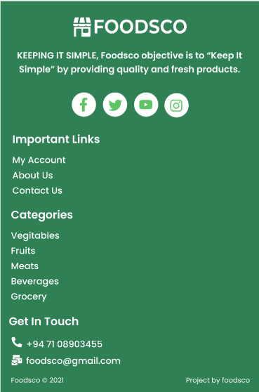

Furthermore, at the bottom of the page, we put a footer with links to the other pages.

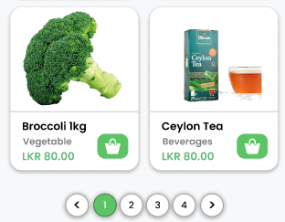

Pagination guides the user to navigate through lists that flow on to other pages

## **1.2 Emotional design**

## The design technique that provides an output to offer the user a positive experience is known as emotional design of a user interface. In general, the first impression that the user has is the entrance point of the emotional design. This design strategy is used by UI/UX designers to elicit a favorable emotional reaction from the user.

## The colors utilized in this mobile site are mostly lime green in the header, green in the footer, and white to light grey as the background color of the pages. Icons also have a color that matches the program background, which might assist the user understand the functions. The usage of a separate color scheme for the header and footer is used to indicate a specific location in the program. These colors were chosen to simplify the mobile site and provide the user with a more calm and serene environment with low contrast when using the site.

## Typography is very important in emotional design. In such an emotive design model, typography should be able to soothe the user and provide a pleasurable experience when browsing the mobile site. In this regard, we employed a minimalist font style and font appearances in this mobile site as a result, it is extremely clear and legible for the user. Because it has been employed in a well-thought-out hierarchical arrangement as well as an intuitive manner, the Poppins font type provides additional simplicity and color to the site. The colors used for the fonts used in various areas are designed to offer consumers a more creative impression.

## Before any textual data is displayed, the user's eyes are drawn to images that contain increasing amounts of information. Those images instill emotion in the user's imagination even before he reads the written contents. Images have been employed in this mobile site to guarantee that the user understands what the site's aim is. The photography was picked to accentuate the mobile site's idea. Along with photography, additional imagery such as iconography have been employed to provide the user greater meaning and feeling about the information included in the textual data.

## Users should be able to understand the language used. To notify readers about relevant facts, we chose plain and simple English. If a user can understand the information provided in an image or container, it will improve their first impression of the application.

## 

## 

## 

## 

## 

## 

## **1.3 Use of colour**

### **Design**

Selecting colors to a application is major task since it represent the application. At the first glance user would want to stay in the mobile web application if the color combinations are correct and eye-catching. Color combinations can directly effect the mobile web application if it doesn’t meets the eye. The user would feel uncomfortable surf through the application if the colors are high contrasting and texts are in color where its hard to read. So it’s better to get good color combinations when designing the application.

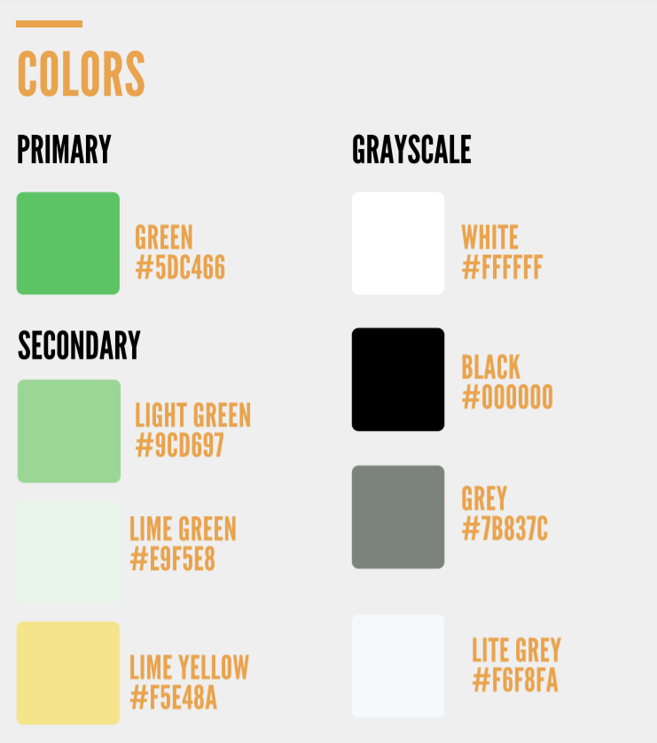’

We selected a light color palette to make our website, which is built on a marketing/promotions platform, feel more welcome to users. The color green is both eco-friendly and user-friendly. We chose light green and lime green to create a pleasant and invigorating experience, as well as a bright and exciting hue that gets the user curious and keeps them scrolling for more goods and specials in order to increase sales for the grocery shop. The color Lime Yellow additionally aids us in emphasizing the most significant aspects of our website. Also we picked the color green because of its communicative nature and relaxing atmosphere of trust.

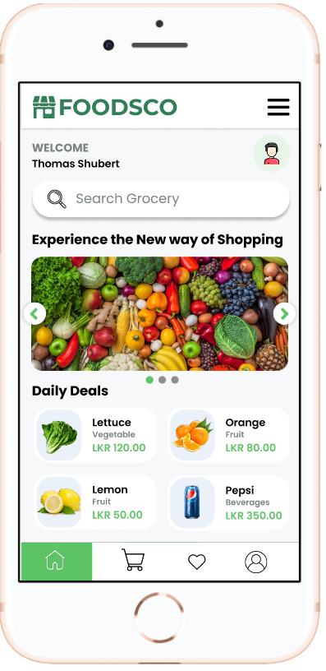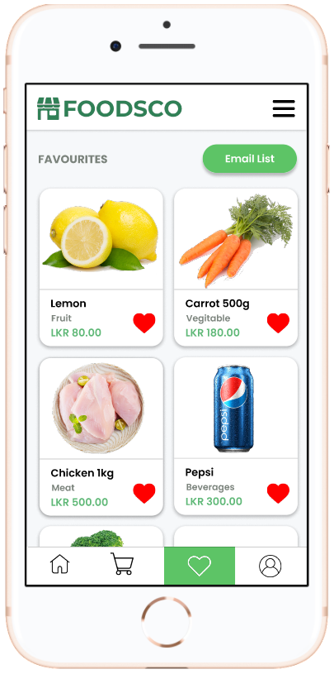

So we used Green on buttons (Example: Sign in, Checkout, Proceed), while offering instructions to users (Example: sign in, Scan the QR Code), and links across the website. For the cancel buttons we used black text in grey background to let the button look unique compare to the confirm button.



To balance the user experience with a strong contrasted mood, the primary backdrop color is white, which offers a pure and basic sense. In order to give clients with the essential visual help, the color white has also been utilized as the text color for primary buttons, which provides a better contrast.

## **1.3 Typography / consistency**

### **Design**

Typography is important in this mobile web design. It was not just about selecting the ideal font style, but also about the font's look, size, and the purpose of using the font styles and sizes. Typography is used to trigger emotions and deliver a message to the user.

The font styles **Poppins** have been used consistently in all pages of this mobile site to enhance accessibility since they are extremely readable to any type of user.By having a low stroke and a strong x-height contrast, these typefaces adhere to typographic rules. This design is often used in current applications, allowing us to communicate a contemporary atmosphere while improving readability and legibility.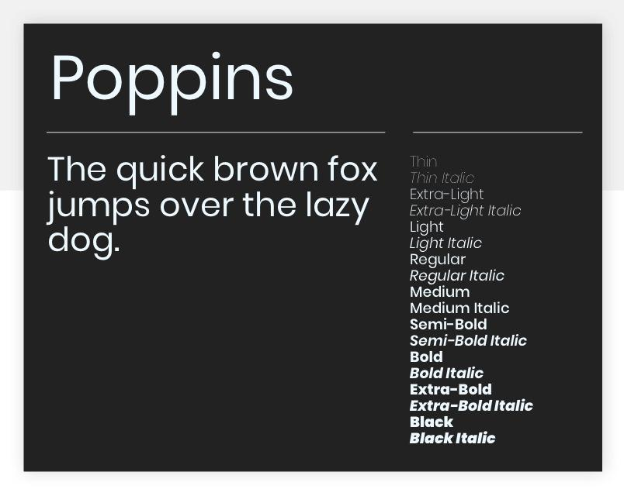

Different font sizes are established in the mobile application based on readability and significance. The font sizes for the headers, subheadings, descriptions, and buttons are all uniform.For example, the names of the individual page's headers have a font size of 18px on the iPhone and 26px on the iPad, which is consistent with all of the header titles on both devices.

### **Code to ensure consistency**

Because of the background color utilized in such regions and elements, the text color in the footer and primary buttons is set to white. When the writing is white, it draws attention to the elements and makes it easier to read.

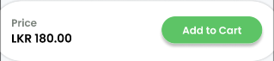

### 

### 

## **1.4 Photography / consistency**

### **Design**

Images plays a key role in making the application more eye-catching. Along with the color combinations images also plays a part in making the user interact with the application more valuable. We have chosen to incorporate additional photographic pictures into our site. Because pictures are more likely to convey realistic information than drawn visuals, using genuine photographs is critical for a marketing-based domain such as a grocery website. This will assist us in increasing trustworthiness, while the client will benefit from easier selection and a more user-friendly environment. We utilized graphics in our gamification section, as well as on promotional carousels, offers, and various extra sections, to get visitors excited and give them a welcoming sense while visiting our website

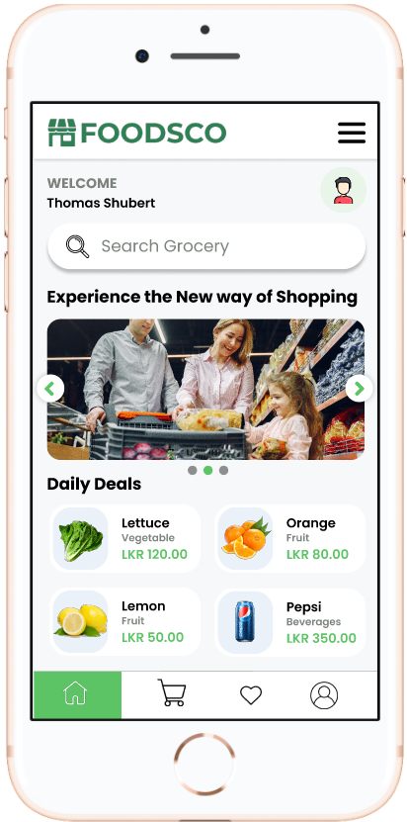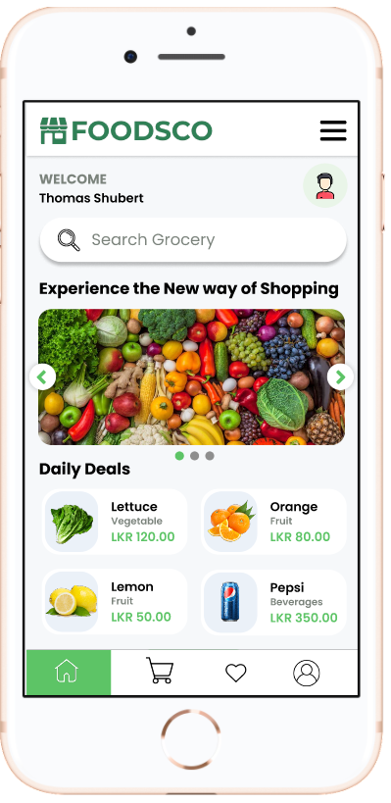

In the gamification the background image is used in every page the gamification layout pages to let the consistency of using images rather than having a plain background to let the user feel more comfortable when using the game.

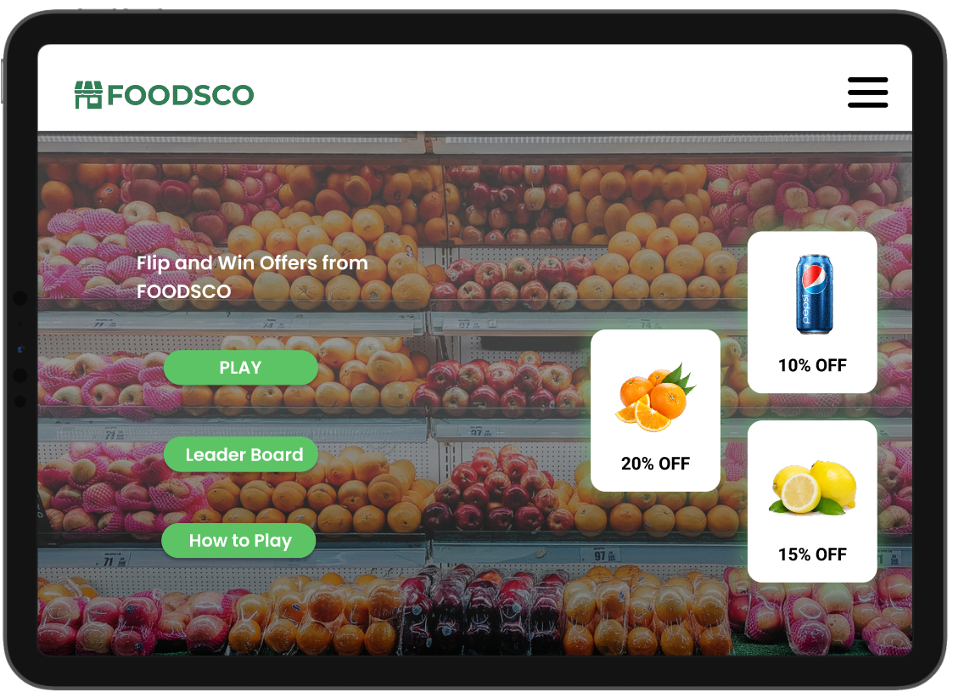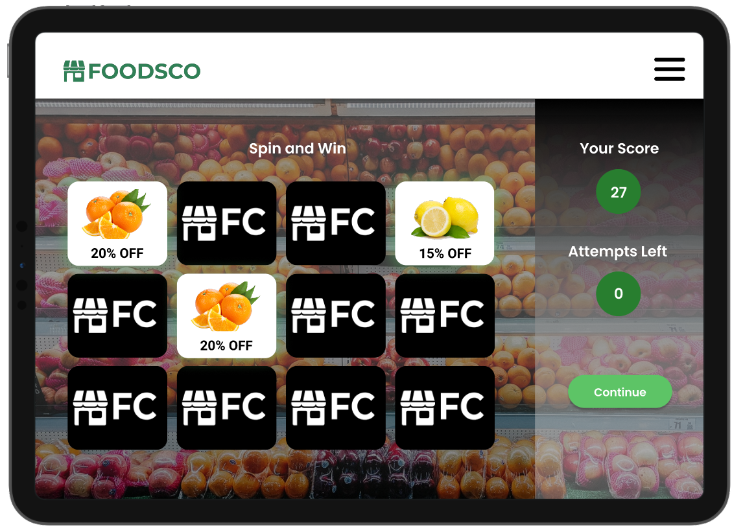

## **1.5 Gestalt principles grouping**

The gestalt principles explain how individuals group identical pieces and see patterns in things.When creating the user interfaces for our mobile application, we used Gestalt concepts of grouping to make the user interfaces simpler and more structured, so that users can grasp the program's information immediately.

### **Design**

**Similarity**

The law of similarity, which states that items with similar properties should be grouped together, was implemented to our application design by showing the goods as a grid, integrating product data inside a card, and grouping the navigation bar and footer elements. This makes it easier for the user to recognize and comprehend different portions of the application, as well as to conveniently take the material. Figures 1 and 2 depict several such applications in our mobile application.

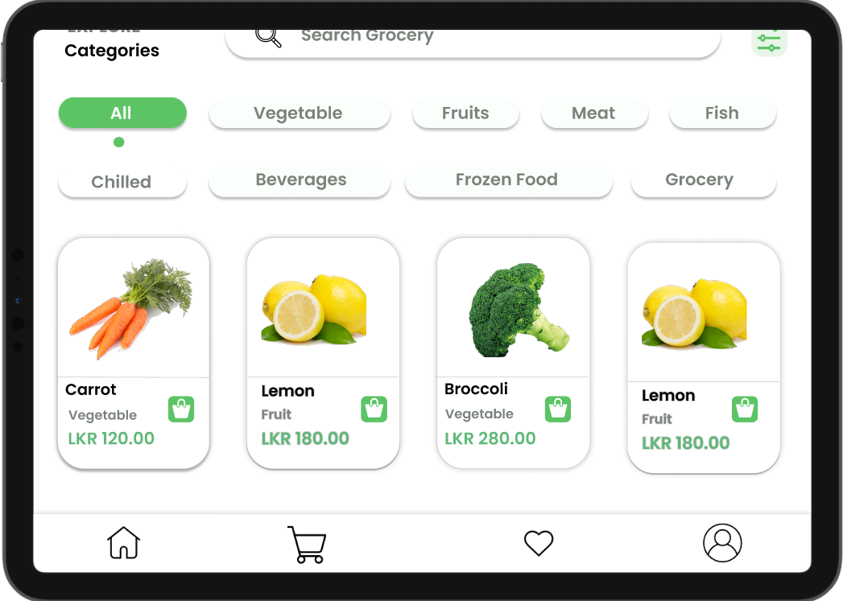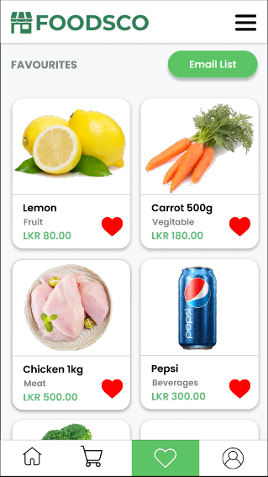

**Proximity**

Figure -(need to add) -is a product card included in the product information. Because of the close proximity of the UI components and the usage of a card to emphasize the text, the user is led to believe that all of the elements present, such as the product name, add to cart button and price, all relate to the same product and its functionality. This is how the user interprets the complete card content.This principle is used across the program in menu bar wishlist and carts.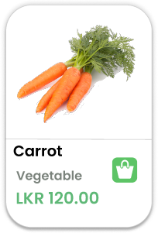

**Continuity**

## Continuity refers to the usage of UI components to move the user to the next route and direction, hence increasing user happiness.

As seen in **<Need to add figure>**  the user is guided to move and continue on to the next step in the mobile web app through the use of pagination.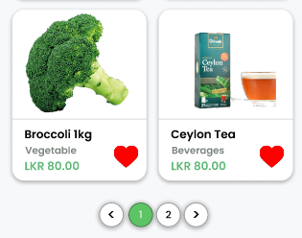

## **1.6 System response & feedback**

System response and feedback are important because that will let the user know of the action that was taken have competed or not. The system feedback would be popped when the user perform an action like removing an item from list asking if the user wants to remove it from the list or filling details in a form and after submitting the form the system will provide the feedback of the form was submitted successfully or if a error occurs after. Below the system feedback that has been used in the prototype are listed

* After a successful a login system response will pop up welcoming the user to the system
* After a successful registration a system response will pop up welcoming the user to the system
* After user add an item to the cart a system response will pop up saying the item was added to the cart.
* When the user removes an item from the cart the system will ask the user to confirm if the item needs to be removed if yes then the system response would pop up saying the item was removed from the cart.
* When user add an item to the wishlist a system response would pop up saying the item was added successfully.
* If the user removes an item from the favourite list the system would ask to confirm if the item should be removed from the list if so then a system response would pop up saying the item was removed.
* In the favourite page when user select the email list button a pop up will ask the user to enter the email after submitting a system response will pop up saying the favourite list was send to the email.
* After a order confirmation a feedback form will be prompt asking the user to rate and give feedback on the order. After submitting the form the system response will pop up saying thak you for your feedback.
* In the contact us page user cab send feedback of the system anytime.Upon submitting system response would pop up thanking for the feedback.

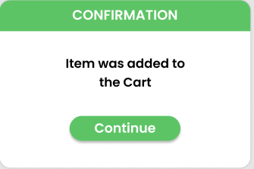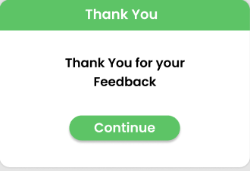

## 

## **1.7 Gamification**

The gamification is added to increase the user interaction with the web application. With the discount promo code as a gift and points system to crate the leaderboard would encourage the user to interact with system more. The discount promo codes can be used to redeem the discounts when the user palace order. This process would certainly encourage the user to play the game ass well as place an order in the system. The game process is explained as bellow,

* The user will have 3 chances to flip the cards

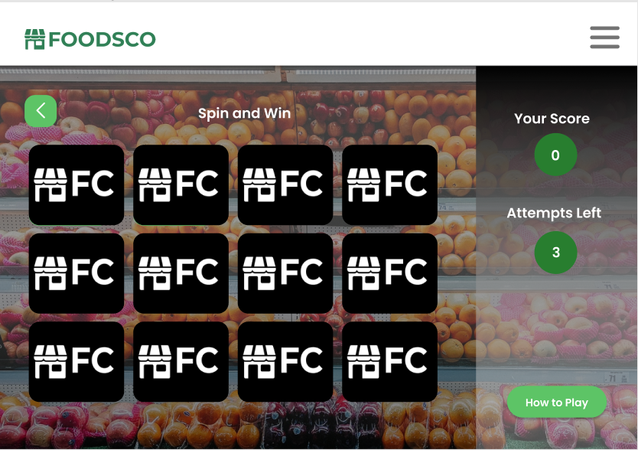

* User would have to match same 3 cards to get the full discount.
* If the user gets 2 of the same card ½ of the discount and if the user gets 3 different cards no discount will be given.

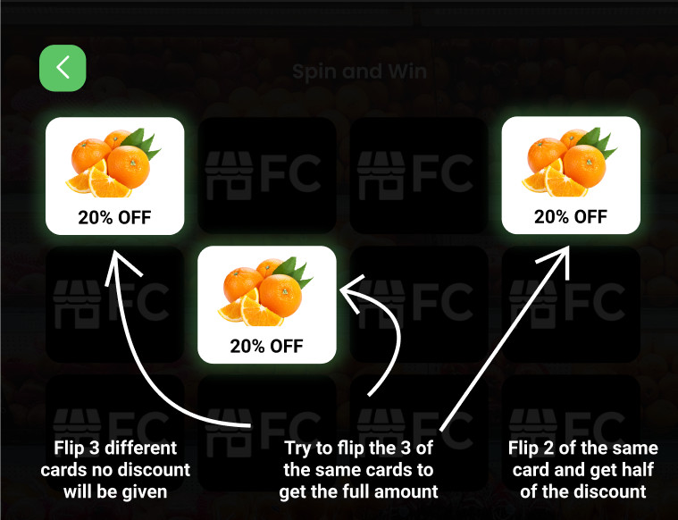

* The points will be given as follow.

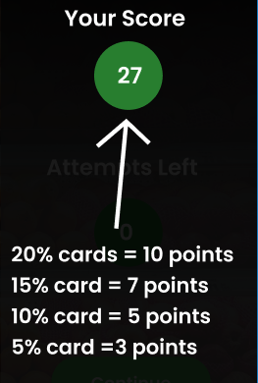

* After the 3 attempts have been used the user would get the promo code to redeem the discount when placing an order

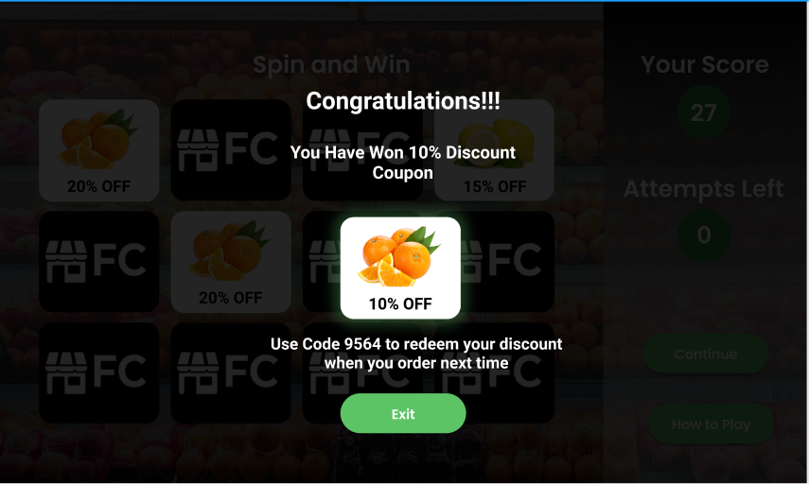

The user can navigate to the game using the menu and also can access the leaderboard as well.

## **1.8 Directing the user to content and use of emphasis**

* **Alerts**

## 

* **Radio Buttons**

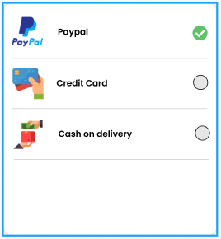

* **Buttons**



* **Sliders and Radio Buttons**

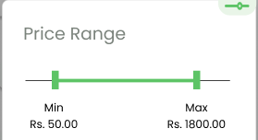 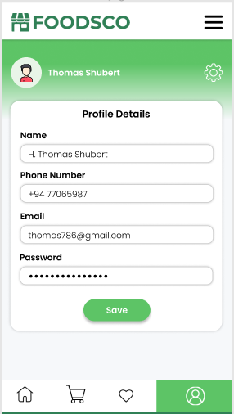

## The function of UI buttons in ensuring a pleasant user experience is critical. These

## components aid in the completion of certain tasks such as purchase, checkout, and

## proceed, as well as linking to other pages on the website. We utilized one tap to

## perform tasks throughout the website. It is a simple approach for the user to complete

## the required activity. Because text buttons have a low level of emphasis, they are

## employed to keep the user's attention in normal material. Buttons are created with

## appropriate visual cues since it is critical for the user to interact with the program in a

## variety of ways. In this scenario, the button shape, size, and color are highlighted, and

## the button size conforms to the thumb rule of being large enough for the user to click

## on it. Buttons are considered responsive components when they are utilized on

## multiple screens of the website. According to design researchers, when the user is led

## towards the center, information processing of an element is accelerated. As a result,

## we utilized flat buttons with curved edges. To preserve uniformity, this is followed

## throughout the website.

## 

## 

## 

## 

## 

## 

## 

## 

## 

## 

## **1.6 iPhone vs iPad**

a) Categories page

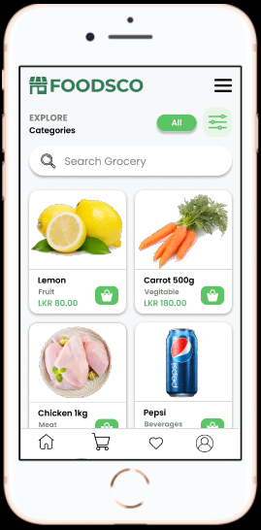

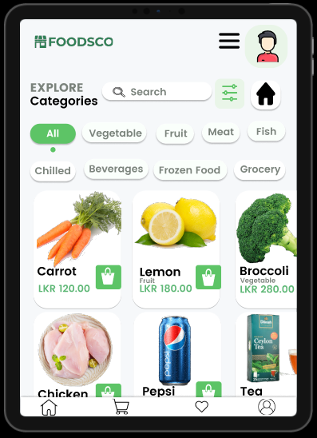

When compared to the iPhone display, the iPad display has greater space, which is utilized to display more material in a more attractive manner than the iPhone, and positioning has been altered to make it easier for users to engage.

b) Home page

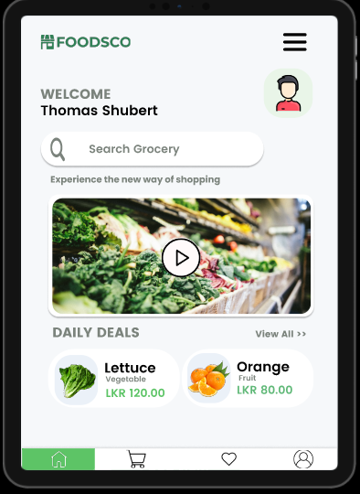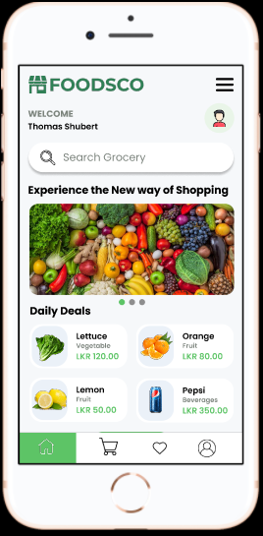

The iPad layout has been used to maximize the usage of the large display, and the user may see a video related to the discounts of the products. A slide show is used on iPhone to present all product details and discounts.

c) Favorite page

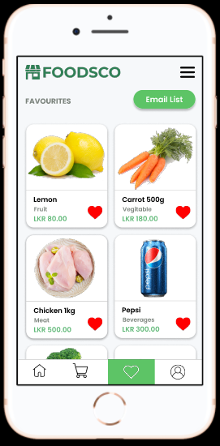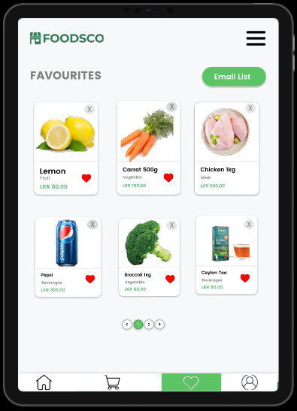

We cropped and resized the images to fit both iPhone and iPad screen sizes, and on certain pages, we used vertical scroll bars to display the same image.

### 

### **References**

Icons - <https://www.flaticon.com/free-icons/online-store>

Images -<https://www.cleanpng.com/>

Images - <https://www.pexels.com/>

Colors - <https://coolors.co/>

[Designing The Information Architecture (IA) of Mobile Apps | Applikey (applikeysolutions.com)](https://applikeysolutions.com/blog/designing-the-information-architecture-ia-of-mobile-apps)